App Development Courses/Certificate Mississippi Curriculum Framework
Apple/Swift
Same CIP as IST 11.0201 Computer Programming/ Programmer, General Same CIP as IST 11.0202 Computer Programming, Specific Applications

July 2026

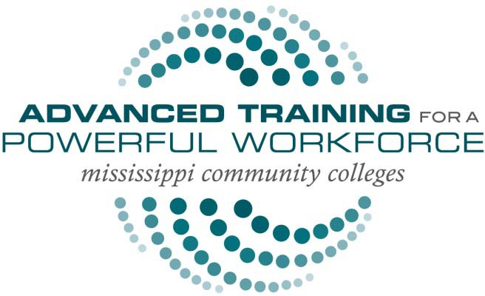
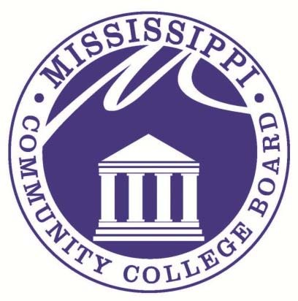

Published by:
Mississippi Community College Board
Division of Workforce, Career, and Technical Education 3825 Ridgewood Road
Jackson, MS 39211 Phone: 601-432-6155
1
Email: Curriculum Email

Faculty Writing Team Members
Anthony D'Angelo, Meridian Community College
David Rose, Hinds Community College
Roderick Kwan, Hinds Community College
Robin Hayes, Mississippi Gulf Coast Community College
Dr. James Gruich, Mississippi Gulf Coast Community College

Administrator Writing Team Members
Dr. Jarius Johnson, Dean of Instruction, East Mississippi Community College
Patricia Corrigan, Associate Dean of Career and Technical Education, East Mississippi College
Dr. Lori Smith, Dean of Workforce Education, Meridian Community College
Joseph Knight, Vice President Workforce Solutions, Meridian Community College
Timothy Crisler, Dean of Technology- CTE, Hinds Community College
Rod Tolbert, VP of Instruction, Jones College
Jason Mattox, Associate Vice President, Northeast Mississippi Community College
Dr. Bobby Ghosal, Assistant Dean of Teaching & Learning, Mississippi Gulf Coast Community College
Dr. Monica Donohue, Dean of Teaching and Learning, Mississippi Gulf Coast Community College
Millie Bordelon, VP of CTE & Community Campus, Mississippi Gulf Coast Community College
Business and Industry Contributing Team Members
Brayden Coleman, Information Technology Coordinator, Mississippi School for Mathematics and Science, Columbus, MS
Aaron Brooks, Director of Information Systems, Mississippi University for Women, Columbus, MS
Steven Eaton, Cybersecurity Incident Response Analyst, Evolver Inc., Reston, VA
Erin Weaver, Technology Coordinator, George County School District, Lucedale, MS
Allen Fretz, IT Program Manager, Paccar Engine Company, Columbus, MS
Jodi Harris, Sr Director of Enterprise Public Sector, Verkada, Ocean Springs, MS
Tylon Malone, Computer Technician, West Point Consolidated School District, West Point, MS
Brent M. Shields, Columbus AFB Network & Data Center Manager, Abacus Technology Corp, Columbus, MS
Nick Jackson, IT Systems Administrator, Relias Healthcare, Tupelo, MS
William Alford, System Administrator, City of Starkville, Starkville, MS

Office of Curriculum and Instruction Team Members
Dr. Scott Kolle, Director of Curriculum and Instruction, Mississippi Community College Board
Ms. Eboni Mangum, Curriculum Specialist, Mississippi Community College Board
Demarius Tolliver, Curriculum Specialist, Mississippi Community College Board
Dr. LaToya Sterling, Assistant Director for Professional Development and Training, Curriculum Specialist, Mississippi Community College Board

The Office of Curriculum and Instruction (OCI) was founded in 2013 under the Division of Workforce, Career, and Technical Education at the Mississippi Community College Board (MCCB). The office is funded through a partnership with The Mississippi Department of Education (MDE), who serves as Mississippi’s fiscal agent for state and federal Career and Technical Education (CTE) Funds. The OCI is tasked with developing statewide CTE curriculum, programming, and professional development designed to meet the local and statewide economic demand.

Copyright© 2026 by Mississippi Community College Board
For information, please contact Curriculum Email

Contents
Adoption of National Certification Standards 5
Industry Job Projection Data 6
Articulation 6
Industry Credentials, Certifications, and Professional Licensure 6
Dual Enrollment 6
Research Abstract 7
Revision History: 7
Program Description 8
Suggested Course Sequence 9
15-hour Technical Certificate 9
Information System Elective Courses 10
Information System Courses 11
Appendix A: Recommended Tools and Equipment 12
Appendix B: Curriculum Definitions and Terms 13
Appendix C: Textbook List 15

Adoption of National Certification Standards
Swift® Playgrounds is a revolutionary app for iPad that makes learning Swift® ® interactive and fun. It requires no coding knowledge, so it’s perfect for students just starting out. Solve puzzles to master the basics using Swift® — a powerful programming language created by Apple® and used by the pros to build today’s most popular apps.
Then take on a series of challenges and step up to more advanced playgrounds designed by Apple® ® and other leading developers.
Announced in 2014, the Swift® programming language has quickly become one of the fastest growing languages in history. Swift® makes it easy to write software that is incredibly fast and safe by design. The goals for Swift® are ambitious: they want to make programming simple things easy, and difficult things possible.
For students, learning Swift® has been a great introduction to modern programming concepts and best practices. And because it is open, their Swift® skills will be able to be applied to an even broader range of platforms, from mobile devices to the desktop to the cloud.
Swift Playgrounds
Swift Webpage

Industry Job Projection Data
A summary of occupational data is available from the Mississippi Department of Employment Security.
MDES Labor Market Information

Articulation
Check with the local community college CTE administration for articulation agreements.

Industry Credentials, Certifications, and Professional Licensure
As curricula are revised or developed for Career Technical Education (for credit) programs at Mississippi’s community colleges, appropriate industry credentials/certifications/professional licensure are identified (where applicable).
Each community college cooperating with businesses/industries in their college district determines if and when industry credentials/certifications/professional licensure are warranted.

Contact each community college for more information.

Dual Enrollment
See the “Procedures Manual for Dual Enrollment and Accelerated Programs”
Dual Enrollment

Research Abstract
In the spring of 2026, the office of Curriculum met with Apple Consultants and all Mississippi Community Colleges to determine the need for the apple swift courses. Two courses were developed for all students in the Information Systems Technology Programs of study to use as electives if desired. The Swift assessment can be taken for the purpose of certification in programming.

Revision History:
2019 Mississippi Community College Board
2026 Mississippi Community College Board

Program Description
The Mobile App Development curriculum is designed to help build a solid foundation in programming fundamentals using Swift as the language. Throughout this course, students will get practical experience with the tools, techniques, and concepts needed to build a basic iOS app from scratch. Students will also learn user interface design principles, which are fundamental to programming and making great apps.

Swift is a powerful and intuitive programming language created by Apple for building apps. It makes programming easier, more flexible, and more fun. Swift is not only great for getting you started with coding. It is designed to scale from writing the simplest program, like “Hello, world!” to the world’s most advanced software.

Suggested Course Sequence

15-hour Technical Certificate
Course Number | Course Name | Semester Credit  Hours | SCH Breakdown Lecture | SCH Breakdown Lab | Total Contact Hours | Lecture Contact Hour Breakdown | Lab Contact Hour Breakdown | Certification Information
IST 1283 | Programming Principles with Swift | 3 | 2 | 2 | 60 | - | - | -
IST 1453 | *Principles of Mobile App Development | 3 | 2 | 2 | 60 | - | - | -
IST 2453 | Mobile App Development | 3 | 2 | 2 | 60 | - | - | -
- | Electives | 6 | 2 | 2 | 60 | - | - | -
- | Total | 15 | - | - | - | - | - | -
The asterisk (*) denotes course requiring swift certification

Information System Elective Courses

Course Number | Course Name | Semester Credit Hours
IST 2533 | IT Project Management | 3
IST 293 (1-3) | Special Problems in Information Systems Technology | 3
- | Instructor Approved Electives Per Local Community College | -
- | Total | -

Information System Courses
Student learning outcomes and other course information for IST classes can be found at: MCCB Curriculum

Appendix A: Recommended Tools and Equipment
Capitalized Items
Mac Book Pro 2.3 GHz dual core i5, 128 GB-Space (1per student)

Non-Capitalized Items
iPad Wi-Fi 32 GB (1 per student)

Recommended Instructional Aids
Apple TV 4K 32 GB

Appendix B: Curriculum Definitions and Terms
- Course Name – A common name that will be used by all community colleges in reporting students
- Course Abbreviation – A common abbreviation that will be used by all community and junior colleges in reporting students
- Classification – Courses may be classified as the following:
  - Career Certificate Required Course – A required course for all students completing a career certificate.
  - Technical Certificate Required Course – A required course for all students completing a technical certificate.
  - Technical Elective – Elective courses that are available for colleges to offer to students.
- Description – A short narrative that includes the major purpose(s) of the course
- Prerequisites – A listing of any courses that must be taken prior to or on enrollment in the course
- Corequisites – A listing of courses that may be taken while enrolled in the course
- Student Learning Outcomes – A listing of the student outcomes (major concepts and performances) that will enable students to demonstrate mastery of these competencies
The following guidelines were used in developing the program(s) in this document and should be considered in compiling and revising course syllabi and daily lesson plans at the local level:

- The content of the courses in this document reflects approximately 75% of the time allocated to each course. The remaining 25% of each course should be developed at the local district level and may reflect the following:
  - Additional competencies and objectives within the course related to topics not found in the state framework, including activities related to specific needs of industries in the community college district
  - Activities that develop a higher level of mastery on the existing competencies and suggested objectives
  - Activities and instruction related to new technologies and concepts that were not prevalent at the time the current framework was developed or revised
  - Activities that include integration of academic and career–technical skills and course work, school-to-work transition activities, and articulation of secondary and postsecondary career–technical programs
  - Individualized learning activities, including work-site learning activities, to better prepare individuals in the courses for their chosen occupational areas
- Sequencing of the course within a program is left to the discretion of the local college. Naturally, foundation courses related to topics such as safety, tool and equipment usage, and other fundamental skills should be taught first. Other courses related to specific skill areas and related academics, however, may be sequenced to take advantage of seasonal and climatic conditions, resources located outside of the school, and other factors. Programs that offer an Associate of Applied Science Degree must include all of the required Career Certificate courses, Technical Certificate courses AND a minimum of 15 semester hours of General Education Core Courses. The courses in the General Education Core may be spaced out over the entire length of the program so that students complete some academic and Career Technical courses each semester. Each community college specifies the actual courses that are required to meet the General Education Core Requirements for the Associate of Applied Science Degree at their college.
- In order to provide flexibility within the districts, individual courses within a framework may be customized by doing the following:

  - Adding new student learning outcomes to complement the existing competencies and suggested objectives in the program framework
  - Revising or extending the student learning outcomes
  - Adjusting the semester credit hours of a course to be up 1 hour or down 1 hour (after informing the Mississippi Community College Board [MCCB] of the change)

Appendix C: Textbook List

Recommended Coding (Apple App Development) Text Book List
CIP:11.0201 Apple
Book Title | Author (s) | ISBN
Everyone Can Code | Apple | eBook
Intro to App Development w/ Swift | Apple | eBook
App Development w/ Swift | Apple | eBook
AP Computer Science Principles with Swift | Apple | eBook

